**1/HOME:**

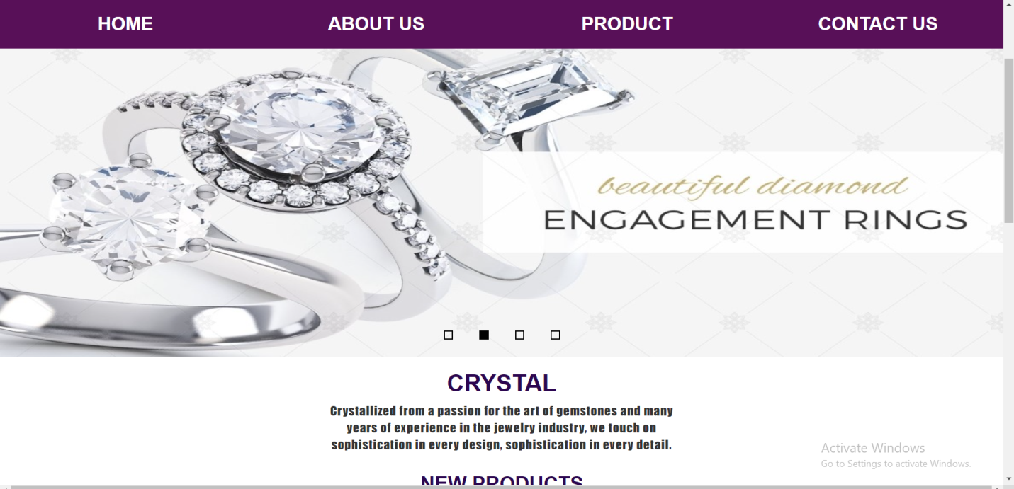

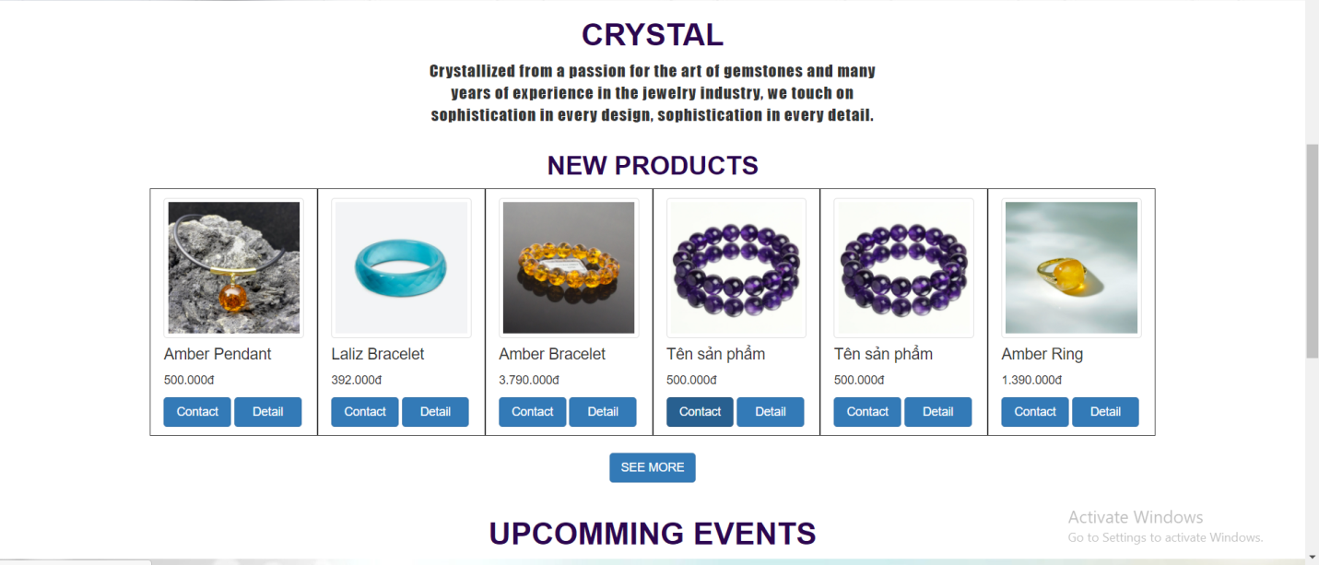

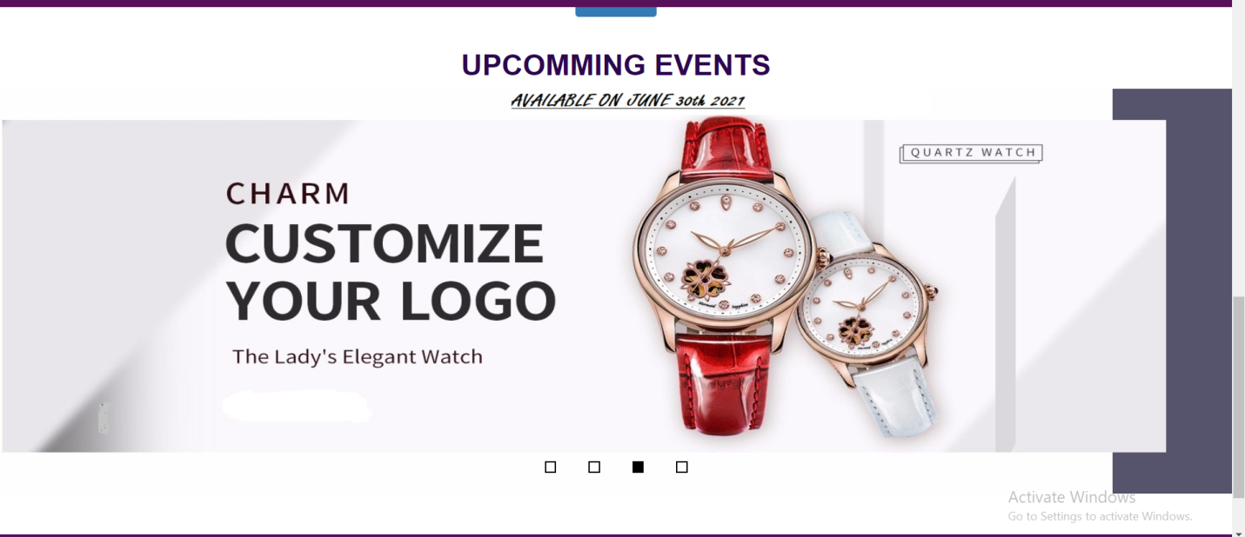

In our homepage, we will introduce about our new products and special offers. Customers can take a look at products which they care. Then, they can click to those products to move to a detail product page which they can see full information.

**2/ABOUT US:**

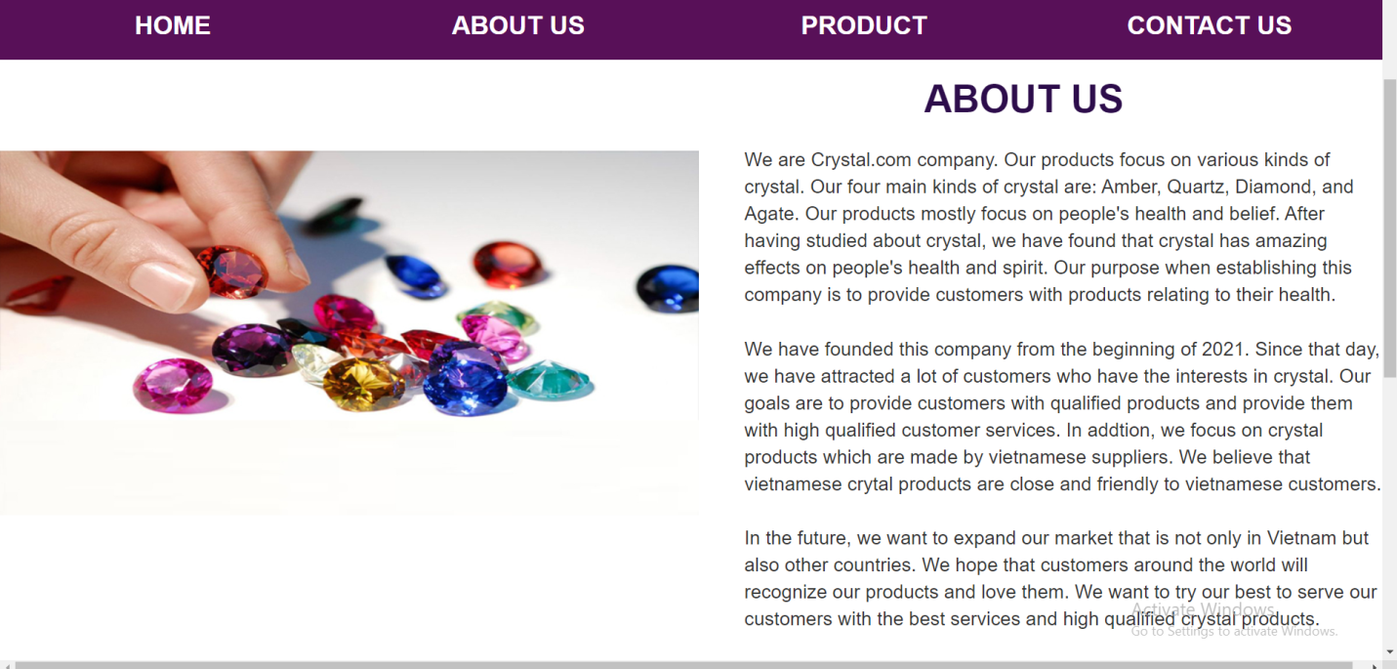

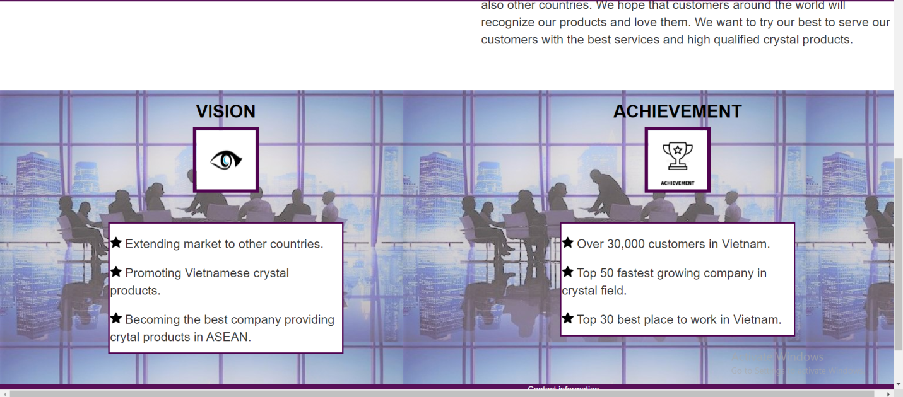

In about us page, we want to introduce about crystal.com company which customers can take a reference about the company. This page provides customers with company information like: company’s products, company’s establishment, and company’s goals.

**3/PRODUCT:**

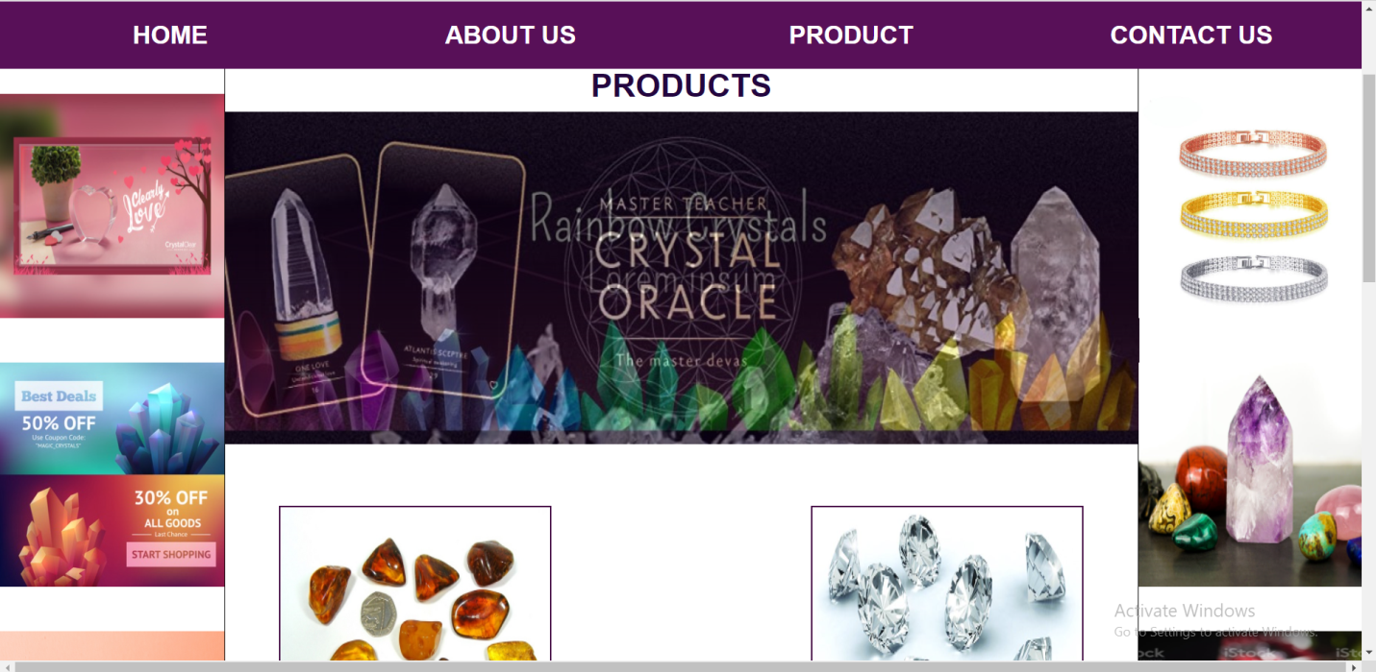

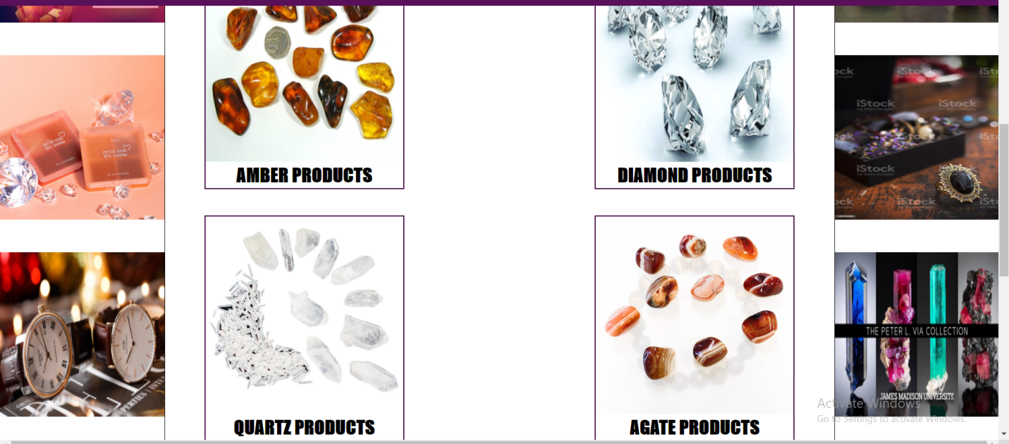

In our product page, we will introduce about company’s main four kinds of crystal. They are: amber, agate, diamond, and quartz. Customers can click on the category of crystal which they like to see products of that kind of crystal.

**4/ CONTACT**

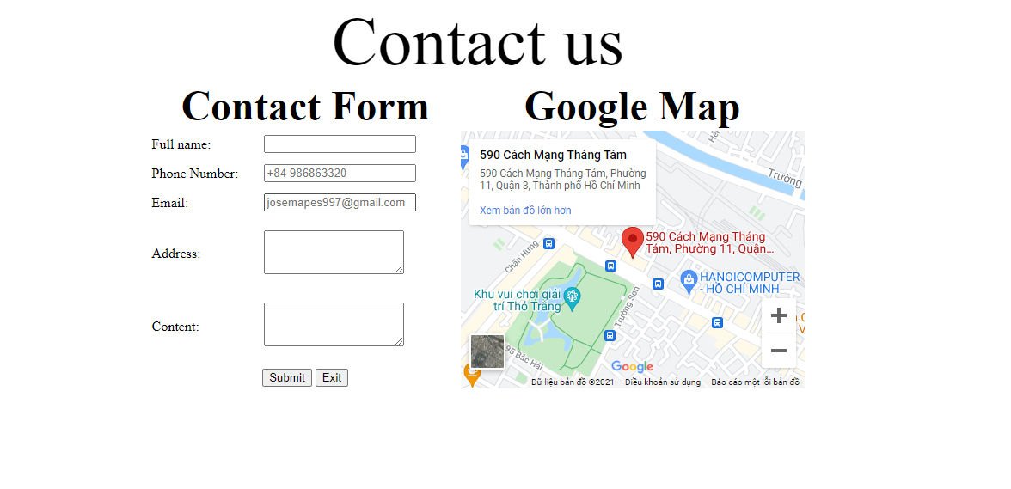

In our contact page, customers can see company’s address. In addition, if customers have any question or problem with company’s services or products, they can fill in the contact form to let the company know their problems.

**5/CATEGORY PRODUCT:**

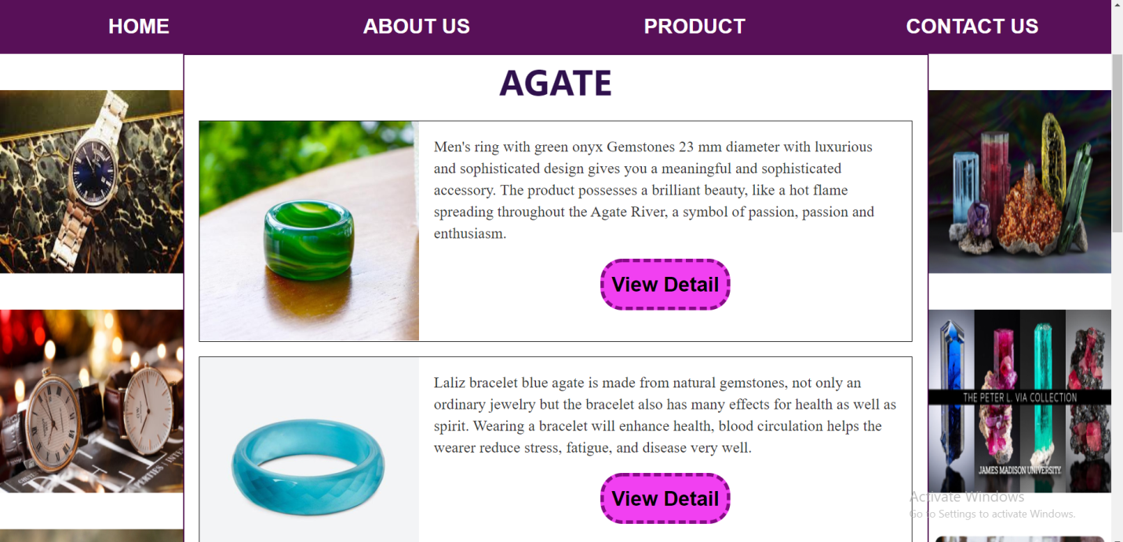

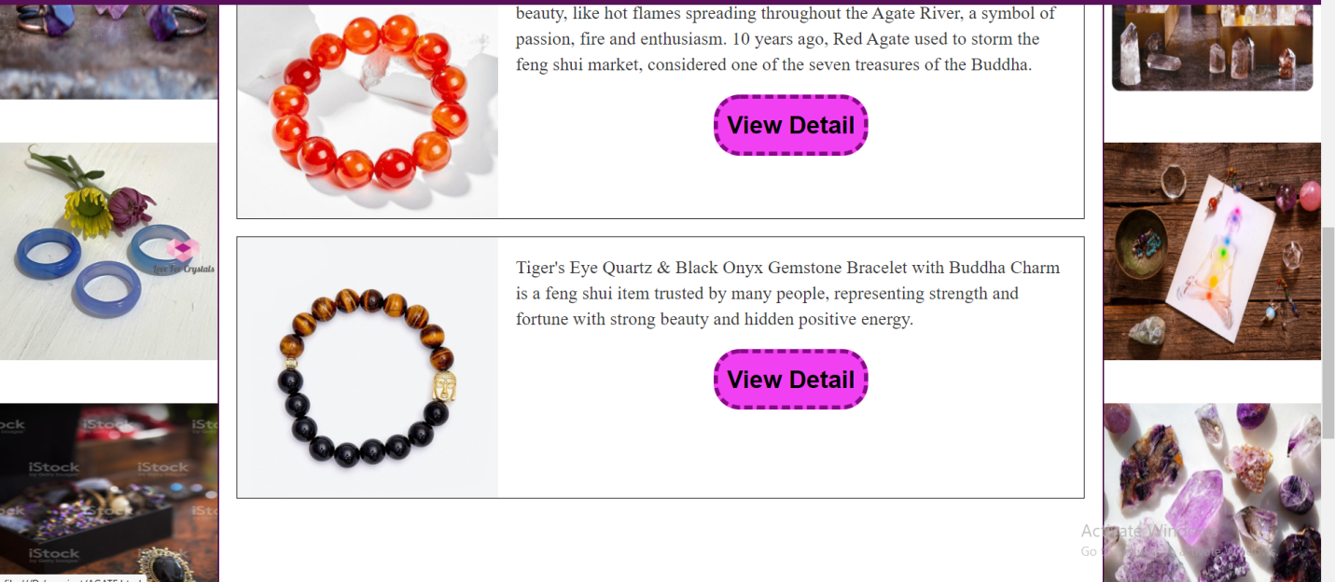

Each category of crystal will have its own category products page. Customers can see products of each kind of crystal in this page. In addition, customers can click on the view detail button to see the detail information about the product which they are interested in.

**6/PRODUCT DETAIL:**

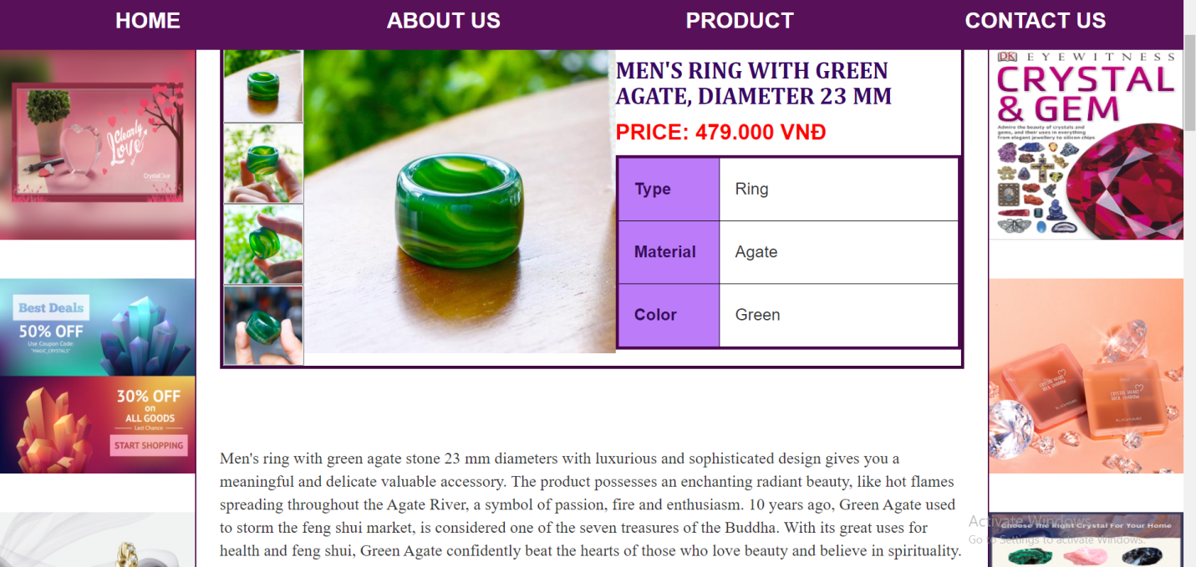

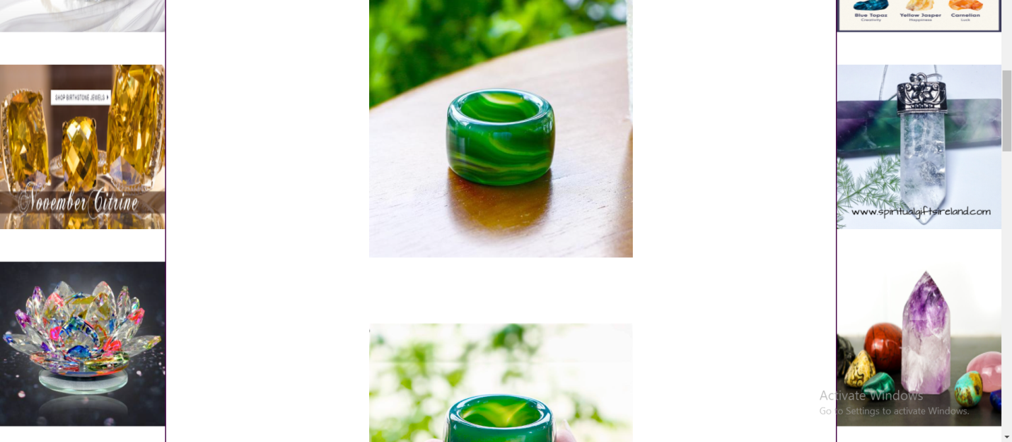

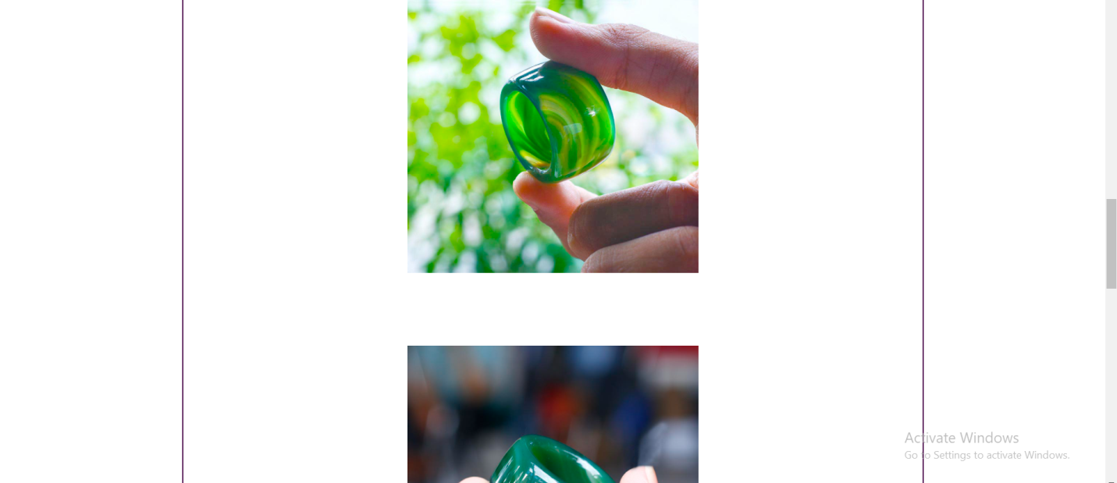

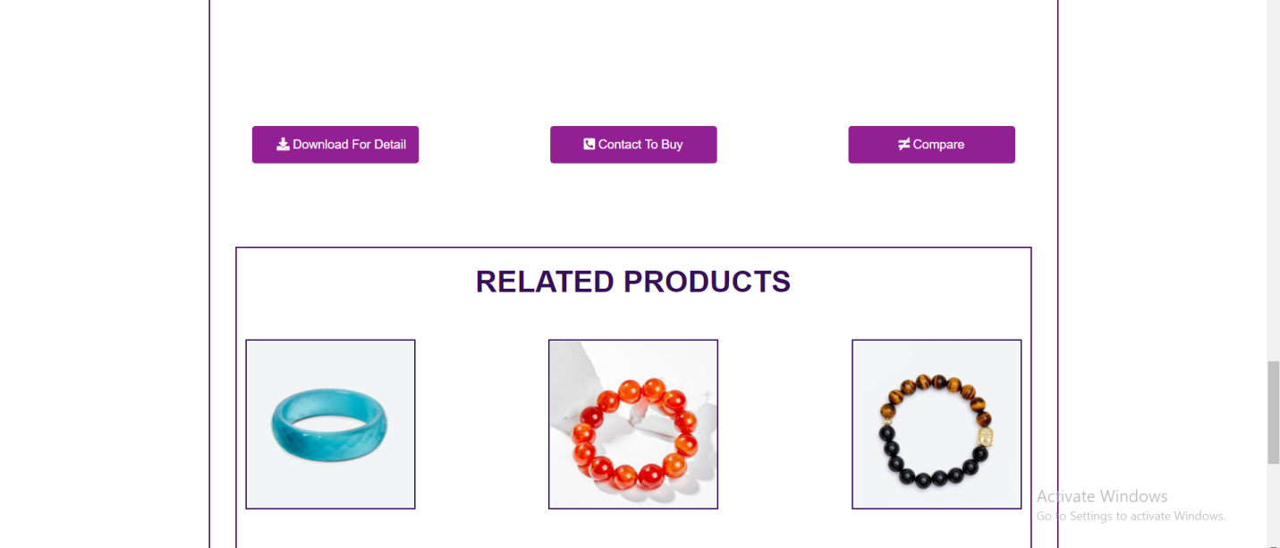

In product detail page, it will give customers a brief summary of the product. Customers can see the price, color, appearance, and material of the product. Moreover, customers can read a brief description of the product. Customers can also read full detail information by clicking on the download for detail button to download file word which covers all information about the product. In addition, customers can contact to buy the product if they like it, and compare the product with other products.

**7/COMPARE:**

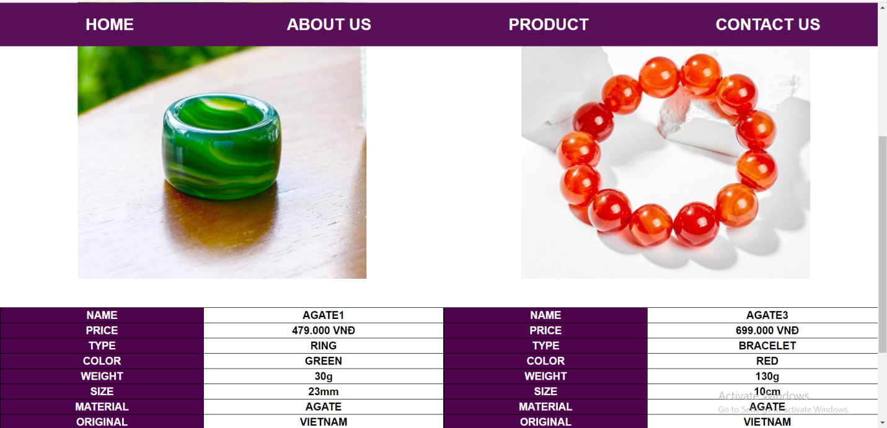

In compare page, customers can compare products of the same category. This page will display parameters of 2 products to help customer can easily to compare.